Please don’t Print, contains many Gif files

Ode solver

To do

Had issues with ODE int wanting functions in terms of t

When its evaluating functions it assumes

Theres more none 0 values in the second deriv matrix this has gotta be the cause of the none symmetric spread

For k by k grid there 2k less values in matrix

ODE stuff

My ode solvers are centred around the ”SolveTo” and “SolveOde” functions. Solve To is the intended user interface for solving odes. It takes a function or list of functions, a list of initial conditions, and the start and end time. Solve To also has optional arguments to specify maximum t timestep, as well as to specify that the initial conditions aren’t initial. The solver to be passed to Solve Ode can also be specified here. Optional event functions can also be passed here.

Solve To does all of the preamble work required before solving the ode. This includes defining the list of t values to solve for. The final time step is often a different length than the others as the specified maximum time steps is used until it would cause the final value to be outside the time range.

There is also a small amount of checking done inside Solve to if the passed function is not a function, the Sympy parser is applied, to turn the input into a function. Another example of input checking is flipping the sign of deltaT if Tn<T0.

If the Initial value kwarg is set to false, t_innitial_condition is set, the ode domain is split in two, at t_innitial_condition the ode is then solved backwards from this point to T0 and forwards to Tn the backwards part is then flipped and appended to the forwards part. This allows for finding the values of ODEs before the initial condition. *I havnt thoroughly tested this as we weren’t asked to do it, maybe it only works properly for even functions or something.*

Solve To is exited either by error or calling Solve Ode. Solve Ode is where odes are actually solved. Solve Ode takes the function to be solved the t array created in Solve To and the initial conditions. Solve Ode takes a Solver step function, as a kwarg. When ran the function applies initial conditions then runs the step function for each t, with the t step size being determined from the difference between current and last t values. As Solve Ode takes a step function as an input it is very easy to change solver.

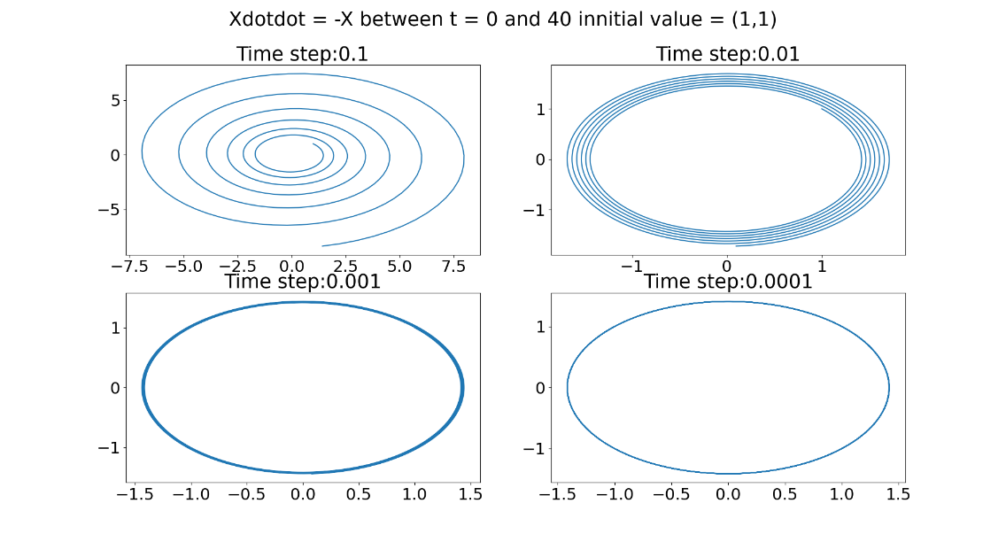Testing

To test my ode solver, I checked against known analytical solutions. The first of these was $\ddot{x}=-x$ this has the analytical solution $sin\left(x\right)$ meaning $\dot{x}$ is $cos\left(x\right)$ this should result in a circle when plotted together.

The behaviour seen is expected, the error in the calculation builds with each timesteps, but is inversely proportional to the timestep.

Rk4 step was used for this test, similar results are seen with Euler’s method, but with greater divergence from the true solution.

Events in Ode solver

Event functions are used to quickly and easily determine when a set of criteria are true along and odes solution, often used for projectile motion to indicate hitting the ground.

If an event function has been passed to Solve Ode, the starting sign of the event function is stored, in the case of event function with more then one return, each sign is stored. The event function is ran at each time step, with the time value and current ode value as parameters. If the sign of the event function changes the event has been triggered. The time step is then saved.

A further optional argument “terminateatevent” can be passed that can take the value of a Boolean or integer. If set to True the solver will terminate at the event, if set to an integer the solver will terminate only after the event has been triggered that number of times.

A previous iteration, attempted to rerun my solver between the time steps that triggered the event function, with a much smaller “deltaTmax” in order to get a more accurate time of event. However if the steps previous to the event were large this essentially means the initial value used to find the more accurate event time is inaccurate. A combination of this serious flaw in the core logic of the method and the significant difficulty in getting it to work had me discard this for a simpler event system.

Cycle finding

Find cycle will find a cycle in each ode system, with or without knowing the period. If no, period is given a phase condition is needed, this is by default the second value in the ode system usually the rate of change of the first value. A function G is then defined with n+1 dimensions where n is the dimensionality of the ode system. The extra dimension is the phase condition. The function should be all 0s when inputted with the starting conditions and period of a cycle. G is then inputted into a root finder, that returns the parameters that make G 0, ie parameters for a cycle in the ode system.

If a period is known the phase condition is not needed, but roughly the same process happens, a n dimensional function is defined, this time with just the start values of the ode system as parameters. This version of G is also passed to root finder, returning the starting conditions that allows the ode system to have a cycle of specified period.

A time dependence is core to cycle finding, the ode solver at its centre, requires functions to have a time parameter even if it has no effect on the value of the function. Many functions without an explicit time dependence are often written without a time parameter, fixing this in code is as simple as adding 2 characters, but could be confusing for a user.

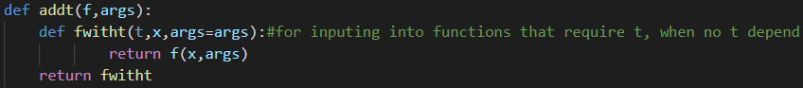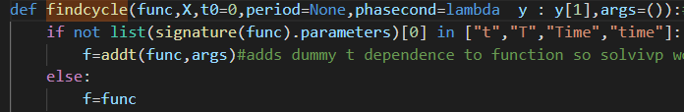To deal with this issue my cycle finding function checks if the inputted function whose cycle is to be found has a time parameter written in common forms if it does not it replaces it with a wrap of the function with the exact same behaviour but a dummy time parameter. Making it compatible with the shooting function.

This probably adds some overhead as each function call to the inputted func, must now pass through the wrapper function but this is not significant enough to notice. To more accurately measure this I timed Findcycle on the 2 versions of the Hopf bifurcation, one with a dummy t one without. Function signatures are shown bellow for clarity.  , the functions are identical other then this difference. The test was ran 100 times with varying parameter values and the times averaged. The version already with t averaged 0.108548637, the version without t averaged, 0.109408185. I thought the difference would be larger, as the function to have its limit cycle found is called many times by Solve_ivp many times for each call of G which itself is called many times by whatever root finder is being used.

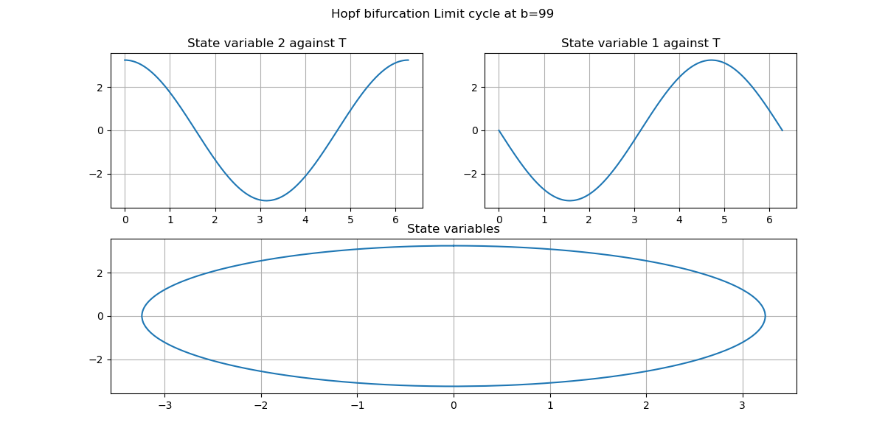

Get all solutions

Ive written a function that using an inputted linear solver finds multiple solutions to a system. This happens by sampling points across the domain inputted and using these as initial guesses. After a solution is found it is only saved if it has not already been found. The function terminates either at the requested number of unique solutions or its maximum number of checks.

Numerical Continuation

Numerical continuation, is a method for tracking solutions to systems of nonlinear equations as a parameter changes. I have implemented natural parameter continuation, and pseudo arclength continuation.

Discretization determines what about the function being analysed (f) is analysed in case of default it is the roots/solutions of f whatever is being looked for by the discretisation function should be a solution to the discretization function. This is required as root finding is part of the continuation process. The discretisation function is a function of f.

If trying to find cycles set, the FindCycles functions root finder to None and pass FindCylces as discretisation function X0 and X1 must be correct shape for discretisation(f(X)), in case of shooting cycle finder this is guess for the period of the cycle then guess for initial values resulting in cycle.

Bifurcation drawing

I have implemented a function that calls Getallsolutions, explained above, at either end of a parameter range. Pseudo arc length parameter continuation is then ran on each of these of these solutions. Completing a forwards pass by continuing from the solutions at the beginning of the parameter range, and backwards pass by working backwards from the solutions at the other end of the parameter range.

Natural parameter continuation works by incrementing the parameter, and finding the solution with an iterative solver, using the solution at previous parameter values as an initial guess. Pseudo arc length continuation works similarly but steps along the tangent to the curve at the previous solution. To find a closer starting point to the new solution.

In implementing Pseudo Arclength Continuation I began by using Sci Py’s Fsolve as the iterative solver, however I found that on many problems such as the hopf bifurcation Fsolve did not converge. When Fsolve doesn’t converge it doesn’t give an indication unless an argument is passed into Fsolve asking for the full output. When Fsolve doesn’t converge it still returns a value of the same format as a root/ the initial guess, these values without proper investigation seem random but usually close to the initial guess.

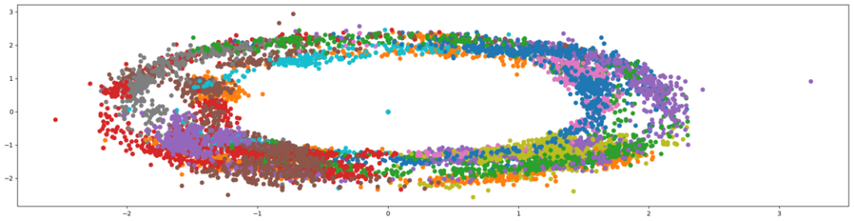One possible use of Continuation would be drawing bifurcation diagrams, this could be done by continuing many solutions from either end of the domain, and plotting all on a single figure. I attempted to do this the Hopf bifurcation. Resulting in this:

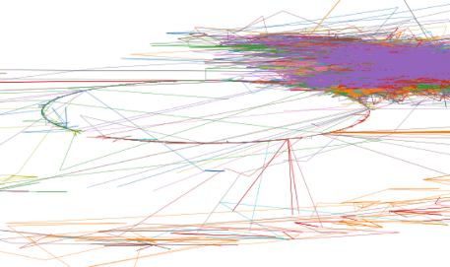Where each dot represents a apparent solution. With the different colours representing the starting points. Seeing this fairly structured looking output led me to believe that it was at least partially correct. However it appears original solutions were found correctly while the root found as part of the pseudo arc length step failed instead returning nearby values most of the time. This resulted essentially random wandering of the domain near the initial correct solution, sometimes being pulled into an actual solution. As the initial solutions were on the ring this resulted in a thicker ring image.

After regrating results with more starting points and smaller parameter step, and plotting as a line graph to better see the ordering of solutions, it became obvious there was a problem from the erratic movement of the solutions, clearly not following along from tangents.

After passing Fsolve “full_output=True” it began returning a flag indicating if it had successfully converged, Fsolve seemed to be converging much less than 50% of the time. This led me to find Scipys “Root”, which Fsolve can be seen as a subset of, Root allows for using a different method if convergence fails, after experimentation it seems “hybr” used by fsolve and “lm” converge most often, these together solve the hopf bifurcation almost 100% of the time.

Despite this addition my arc length continuation still was not behaving, I attempted to draw a bifurcation diagram of the Hopf normal form $+{\left(1,-1\right)}^{T}$ β=1 and β=24. The resulting plot is seen bellow. With the top graph showing each dimension of equilibriums, against the parameter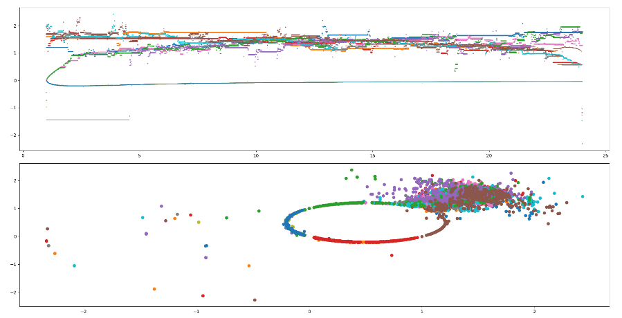 and the bottom showing the x and y of each equilibrium plotted as points. The colours indicate different starting points in the continuation.

After going back to the drawing board, I realised I had misunderstood the algorithm and not included the parameter as a value to be solved for in my arc length continuation and was instead iterating through linearly spaced parameter values such as in Natural parameter continuation. This is probably why Fsolve was failing so often earlier.

This took a long time to notice as I wasn’t looking at the core algorithm as it appeared to be close to working, I had wrongly assumed that if I had made such a fundamental error the output would be far more chaotic if it could run at all. It has been rare in my experience to find an algorithm still partially functions with a core part removed. I mostly put this down to the use of solvers as part of the algorithm.

The 2 values returned by the “G” function passed into a root solver in this incorrect implementation of arc length continuation, would still be 0 at a root of the function at the given parameter value, because of this, Scipys Root was still often able to find a solution to the system being continued at the correct parameter value. This resulted in graphs that looked misleadingly close to correct.

This combined with Fsolve not by default indicating when its failed serves as examples of why things such as assert statements are important, often code is designed to crash as little as possible but sometimes this can be misleading. Behaviour when failing should be considered when choosing functions to use in a program. Root finders used in this context seem to be especially dangerous as they can act in an intelligent -esque manner to still move in the intended “direction” even if other parts of an algorithm are incorrect or failing, resulting in a final output that can hide the issue.

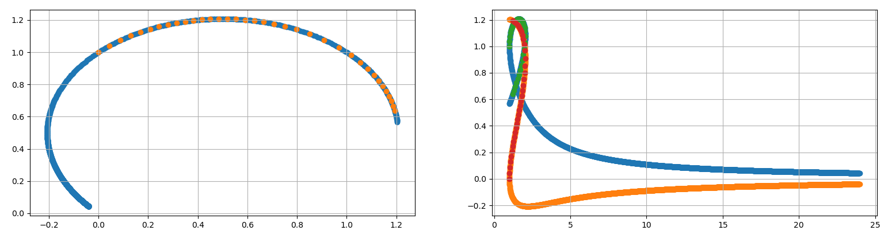The final output from my bifurcation diagram function, for the problem used above as an example was:

Its still not a bifurcation diagram but its at least tracking multiple solutions across the par range

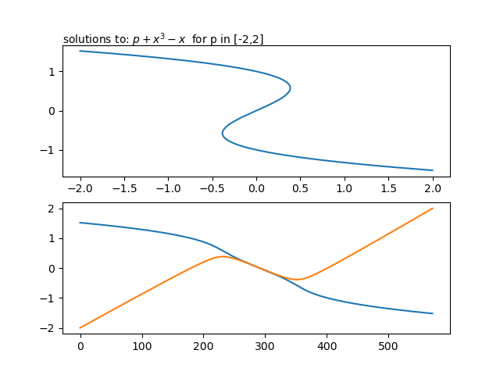Graph bellow shows arc length continuation of polynomial given in notes.

The arc length continuation function can exit in 3 ways, root finder failing, leaving the parameter range, or reaching the max steps. Max steps is an optional argument defined by default as $\frac{100\left(p_{n}-p_{0}\right)}{stepsize}$ This should only stop the iteration in rare circumstances such as the arclength continuation getting stuck in a cycle of the parameter and state variable. It acts as a backup way of leaving the function if the others fail.

A 4th way of exiting the function was created but is now completely redundant. To detect the continuation leaving the intended solution track, the l2 norm between each step was compared with a multiple of the step size, a similar approach was attempted using a rolling average of the differences between steps, however both methods proved to halt continuation often incorrectly. What both these methods are trying to achieve is much better achieved by exiting if the Root finding fails.

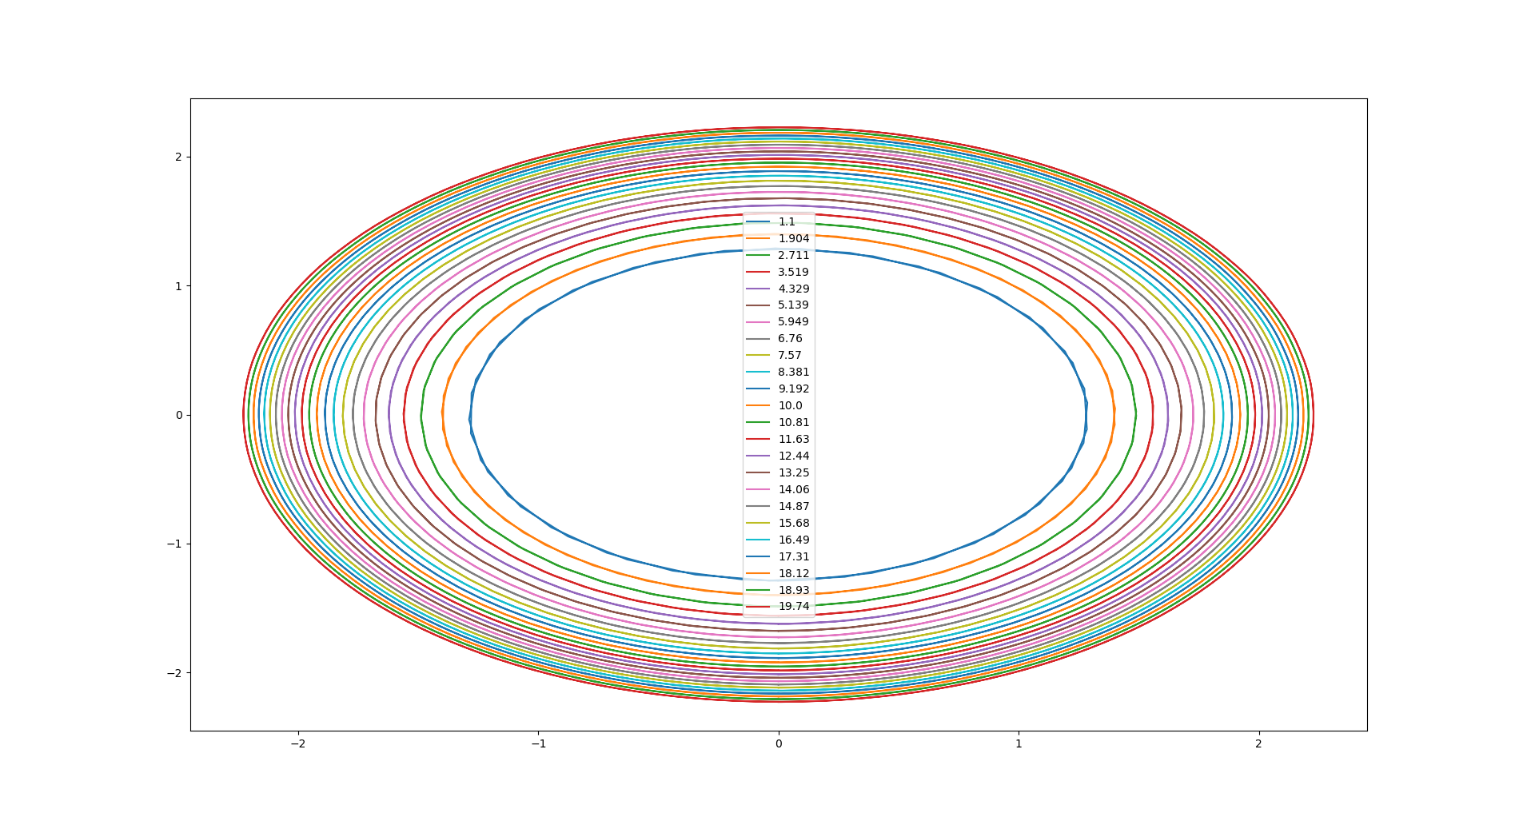I found the interface between the cycle finding and continuation to be one of the more challenging parts of this project. I spent a long time trying to edit my continuation to fit my shooting, before realising my shooting instead needed to change. Numerical shooting defines and then solves a function that is 0 when a cycle is found, by passing this internal function out when no solver is suggested it can then be passed into continuation. The arc length continuation then Solves the function. Passing itself a good guess to make the next solution step much easier.

The graph on the left shows how a limit cycle of the Hopf bifurcation normal form change with its parameter (β). In order to plot this, a set of initial values that would result in a cycle were found using arclength continuation, for values of β between 1 and 24. Every 8th initial value was solved then plotted. The legend values show the β value corresponding to the cycle.

Given that a function returns 0 when it has found what its looking for my pseudo arclength continuation should work for arbitrary functions.

Effects on speed of arc length continuation

By using Root instead of Fsolve I have slowed down my continuation, Root will start by using the same methods as Fsolve, and if it fails it will then use other slower methods. My Solver has the option to pass a different solver such as Fsolve, but Fsolve will not return None on failing to converge, meaning the continuation wont be left when the root finding fails. Root will always be atleast as slow when compared to Fsolve, but is more reliable.

My Implementation of pseudo arc length continuation defines a function G that returns the dot product, of the difference between predicted X and the current guess for X, and the secant. G also returns the function evaluation at current X guess. This function is called many times by the root finder. Originally the calculation of secant and Xprime happened in this function, however as these don’t depend on the variable used by the root finder, these can be moved outside of the function, only needing to be updated every time step, instead of however many times the root finder calls the function per timestep.

As the conditions for leaving the function are determined in run time, checks must be made each loop, this adds up quickly if many iterations are needed, especially because there are multiple distinct exit paths. To reduce this all of the checks are only made every 8 iterations. This is completed by checking if the modulus of the current iteration with 8 is 0. This is a cheap operation to do each step, and means each of the other more taxing checks are done 1/8 times as often. Print statements giving information on progress are also in this block.

When a complicated discretisation is passed continuation is quite slow, as for each iteration the root solver calls the discretisation many times, in the example of shooting this takes

PDE stuff

I’ve included lots of gifs showing heat spread, many of these were created with older iterations of the solvers. if not stated or obvious from context, assume heat spread solved by ADI method.

1d solvers

I began by making the 1d forward and backward Euler and crank Nicolson methods, however after these worked with little additional features, or extensions I moved onto 2d solvers, the vast majority of the time spent working on PDE solvers was on the 2d solvers, I have added all of the extensions to these other than nonlinear LHS function. This should all be compatible and implemented for the 1d stuff but I haven’t had time to thoroughly test.

Setup PDE

Each PDE method shares a lot of the same starting setup, mostly to save time working on different methods, all this set up was wrapped into a function that’s ran as the first step in each solver.

TMDA and sparse matrices

The TMDA algorithm solves tridiagonal systems quickly. I found a python implementation at <https://gist.github.com/cbellei/8ab3ab8551b8dfc8b081c518ccd9ada9>. This implementation is extra useful because it takes the diagonal values as arrays instead of the entire matrix, this means the 0s are not stored saving memory.

Applying initial conditions

A python function of the given spatial domain is passed into the solver, this is ran for each cell then applied to the corresponding cell. As the initial conditions are specified with a python function, almost any initial setup can be specified be it distribution defined by mathematical function or even text written by the initial temperature distribution. Innitial conditions functions should return 1 value for 1 point. The initial condition function is run for every point. With the coordinates of that point passed as argument. Coordinates should be given as a single tuple.

Applying boundary conditions

I wrote a function that applies given boundary conditions to a given domain. It takes a python function of time and whatever spatial domain is being solved for. This allows for a lot of flexibility in the conditions. With the exception of the periodic conditions boundary condition function can apply values from a function to a n dimensional grid. This isn’t implemented for periodic conditions as I added periodic conditions after realising trying to make an Nd solver was very silly.

The boundary condition function should be applicable to all of them methods but as of this moment is only applied to the ADI method and 2d backward Euler.

The Boundary application function also has options for applying the function across the whole domain instead of just the edge, this allows for heat sources. A user could input a heat source function with logic causing it to return 0 in all but where the heat source should be active. The boundary/heat source application function does not need to know anything about this, it simply runs the given function for current time, coordinates of each cell, adding the result onto the cell.

A function used for boundary conditions or heat source should output 1 temperature for 1 set of coordinates, and time. With the coordinates given as a tuple, as the first positional argument, and the time given as second positional argument.

The boundary applying function should also be passed a list of boundary types, if it was wanted to have a heat source and Dirichlet boundary conditions a list containing “heatsource” and “dir” should be passed, as only one function is passed, the same function would be evaluated for heat source and boundary condition, but in the Dirichlet boundary code block only the edges are updated.

|  |  |  |
| --- | --- | --- |
| Key word | Description | Compatibility |
| “dir” | Sets boundaries as equal to evaluation of given function at boundary and time T. | Not Compatible with other Dir conditions. If heat source function is written with care, can be used with heatsource.  Works with periodic, but periodic will overwrite the boundary. |
| “dir+” | Adds Boundaries to evaluation of given function at boundary and time T. Just Dir with a “+=” instead of “=”.  I think this is what Newman conditions are, im going to keep “dir+” as a name as changing it in code doesn’t seem worth it this late. | Same as dir. |
| “dirh” | Homogenous Dirichlet Boundary condition | Same as dir. |
| “heatsource” | Adds evaluation of given function at every point in domain. | If the heat source function is written with care it can be combined with any boundary condition. |
| “periodicy” | Connects top bottom edges | Only Arguably Compatible with “periodicx” as you cant connect 4 sides of a square, without stretching it. Thus breaking $dx=dy$. Works in tests but almost certainly violates something  Will overwrite a Dirichlet boundary condition on the relevant border. |
| “periodicx” | Connects left right edges | Same as “periodicy” |



Top bottom edges connected left right constant Initial: $cos\left(\frac{πx}{4L}\right)+sin\left(\frac{πy}{4L}\right)$

Heat Source Code Shown Bellow

*Homogenous Initial, dirh bounds*

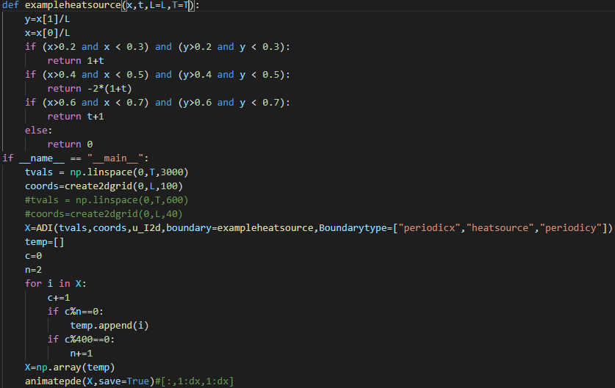

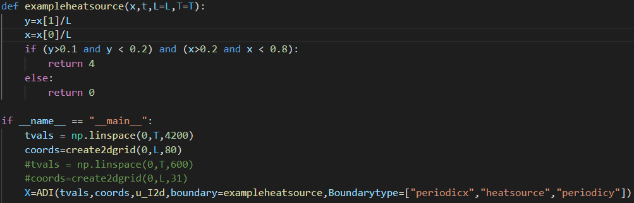This shows code that generates the heat source as well as how to input into the solver. This is meant to serve as an example of how to use my code.

Periodic troubles

I originally tried to implement periodic boundary conditions by simply setting the two connected edges to there average, this almost worked with areas of similar temperature being able to merge over the boundary as they do normally in the centre of a domain, however it was clearly failing on the example shown above with a heat source in near an edge.

I then implemented a forward Euler like step over each boundary, this worked better, but the rate of heat spread elsewhere is partially controlled by the method used, for example my ADI solver is essentially doing 2 steps in 1, obviously the heat spread from 2 steps of the ADI method is not equivalent to 1 of the Forward Euler method. I made a band-aid solution in the form of having my ADI solver call the condition application function twice.

Periodic boundary conditions should be implemented as part of the solver function, however I did not want to add new code and more arguments to each solver. 1 function that applies all types of boundary conditions is also far more satisfying then all but the periodic conditions.

The edges of my domain are treated as special cases that aren’t changed by the heat spreading functions, only by the boundary condition functions. They also are not outputted from the solver by default. As a result of this heat spreading from 1 visible edge to the other visible edge is passing through two invisible rows first. This problem is minimized with higher grid size. The true boundaries can be drawn by commenting 1 line in customreshape().

Animation as testing

Comparing the output of my solvers with known solutions is complicated and adds extra things to be thinking about while trying to work out what’s broken. Being numerical the solutions aren’t guaranteed to be accurate even if I have coded the correct algorithm correctly, meaning unless convergence rates are taken account of I could be failing tests I really should pass. Furthermore, a pass fail, on its own provides little information, on what is wrong, a set of tests could be designed that together gave a fuller picture, but given the massive space of potential ways to incorrectly solve PDEs it will be much easier to get an intuition for what im doing right or wrong if I can see the full picture. The best way of doing this is to animate the full picture.

You can view the full picture for a 1 d heat problem without plotting a heat map, as the temperature of each cell can be plotted as a line and the line animated. However, the most intuitive way to show heat spread is on a heat map. Ive also found these aesthetically pleasing, and satisfying to create.

To judge correctness of an animation ive mostly used intuition. We understand a basic level diffusion and can often see when something is wrong.

A few examples of things wrong that can be picked out quickly are distributions becoming less smooth, and symmetric starting and boundary conditions resulting in asymmetry.

Homogenous Dirichlet, Initial: $cos{\left(x\right)}^{2}+sin{\left(y\right)}^{2}$

Testing by visual comparison is faster, and more descriptive then numerically comparing to known solutions. However to properly verify the solver it does need to be compared to known solutions, as there probably many ways it can look right and still be incorrect. Animation is best used to quickly spot the most obvious issues.

Extending Heat equation solver to 2 dimensions

Originally I naively wanted to try to generalise a solver to N dimensions, as a result I made many choices that attempted to generalise what I was doing as much as possible. As a result much of the “infrastructure” surrounding my solver will accept Ndimensional Domains. A few places in the code where it would have made more sense to have two blocks of code for 2 dimensions, there is a for loop that will only ever iterate up to 2 times for 2 dimensions. Another example of generalisation is, the solvers all take a copy of the spatial domain, as one of their parameters, for 1 d this would just be the list of values to solve for, but in nd it is a list of nd tuples of coordinates to solve for. This allows for applying initial and boundary conditions in the same way for a spatial domain of any integer dimension.

After having far more trouble then I thought trying to perfect 2d I gave up on generalising further.

Each of the 1 d methods has a update matrix that is either multiplied or solved as part of a linear system. This matrix for 1 d problems is 2d, my first attempt was to find a 3d matrix that could multiply my 2 d matrix of temperatures in order to update in the same fashion as the 1 d case. I could not work out how to generalise in this way and found working with 3d matrices difficult. Due to this I moved on to other methods.

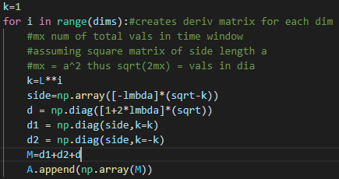The grid is stored as a flat list. If each row of the grid is n long, the under and over element will be at -+n.

|  |  |  |  |
| --- | --- | --- | --- |
| 1 | 2 | 3 | 4 |
| 5 | 6 | 7 | 8 |
| 9 | 10 | 11 | 12 |
| 13 | 14 | 15 | 16 |

This means that the off diagonals from the 1d derivative matrices can be offset further off diagonal by the side length of the grid, resulting in a function of a of a grid value and its 2 vertical neighbours rather then a value and its 2 horizontal neighbours. This can be generalised to Nd as a value adjacent in the Kth dimension assuming all side lengths same will be $L^{K}$ values away in the flat list.

A Down side is the matrices are no longer all tridiagonal, increasing resources requirements.

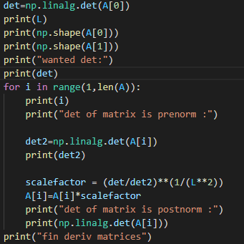This method resulted in highly asymmetric heat spread. With horizontal heat spread being much faster. This is demonstrated in the left gif, it almost appears as if the boundary conditions are only providing heat flux from the vertical boundaries. However there is a constant heat flux from each edge.

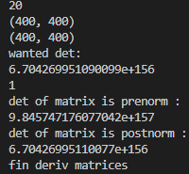 I hypothesised this could be due to the different number of 0s/ magnitude of each of the matrices. I tried to normalize derivative matrices such that they had same determinant, as well as trying to rescale the deriv matrices by other values but this did not fix problem.

Having different matrices for X and Y derivatives does not seem viable. In experimenting with this I created a matrix that finds the X derivative on a flattened representation of a 2d grid. If I transpose the 2d grid before flattening all of the adjacent terms will now be Y neighbours not X neighbours.

If I transpose the grid then apply my X matrix then transose the grid back, I will have the same heat spread in X and Y, forcing the symetry. This method has the down side of failing on asymetrical boundary conditions. If one edge is a heat source the opposite must be to, or haf of the heat from that edge will spread from the oposite edge. The animation on the left with only 1 side a heat source demos this. This afffect strongly resemblems periodic boundary conditions, making this a feature and a bug.

By going back to having only 1 matrix and rotating the domain, the TMDA algorithm can be taken advantage of again.

The first and last cell appear to be incorrect, heat doesn’t seem to spread into or out of them properly. The section bellow discusses this issue.

The gif bellow shows a version of the backward Euler solver with initial conditions $T=cos\left(x\right)+sin\left(y\right)$, and homogeneous Dirichlet boundary. In the bottom left and top right, the far ends of the domain when a treated as a flattened list, there is a visible artefact, this is explainable by these cells not receiving energy from their neighbours but still losing it to the edge. This explanation should also apply to the top right and bottom left to, but this affect cannot be seen there.

In the second gif, the starting conditions and 0 throughout, but each edge cells have a constant heat flux, this is a fully symmetric set of starting conditions yet there is visible asymmetry. The artefact originates in the same corners as the first test.

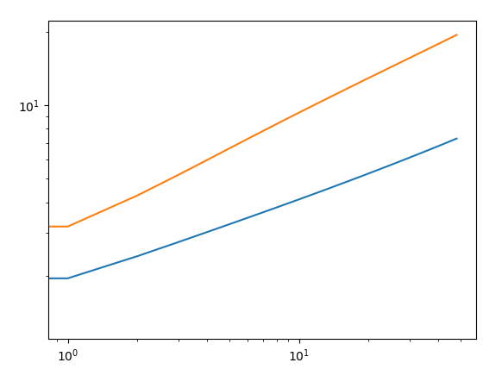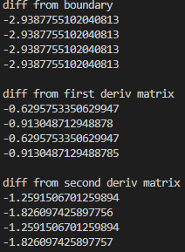As part of the investigation of this issue I printed out each of the differences for each corner, before and after application of boundary conditions. This showed that the boundary conditions were applied correctly. Printing differences before and after derivative process, showed that the difference between corners originates here. The change caused by the derivative matrix was different in the bottom left and top right corners to the top left bottom right corners. A similar pattern continues throughout. This shows the error is in the different treatment of corners, also that problem is symmetrical meaning we only need to keep track of 2 of the 4 corners when investigating this problem. The left and right graphs bellow show the difference between time steps for the 2 categories of corners. These should be the same line. the right shows a log log version of this.

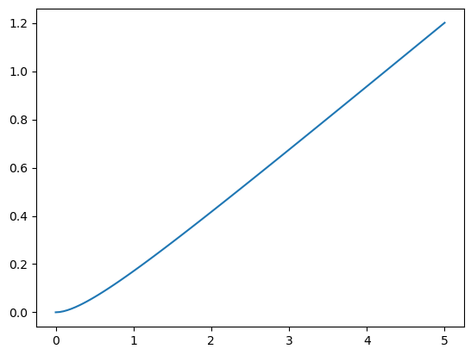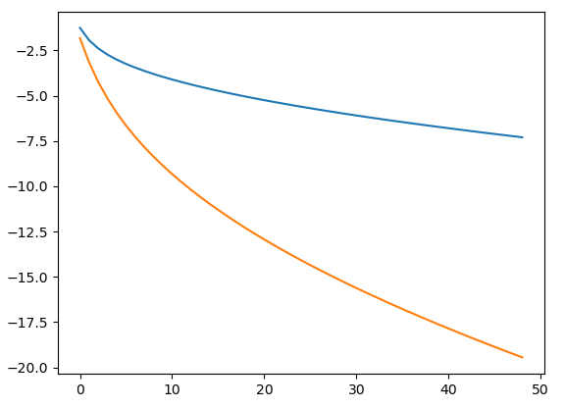This is repeated with different values of lambda, it can also be seen the difference grows linearly with lambda. To confirm this, I modified my backward euler code to out put the difference between corners in first time step. Then produced this plot, showing said difference against 100 values of lambda varying 0,5. The rate of change of this line is about 2.444. This means that the on the first-time step one corner changes $lambda^{2.444}$ more than the other.

I attempted to fix\ mitigate the issue by taking away $lambda^{2.444}$ however this did not fix the issue, after trying to apply a few magic numbers, it became obvious this was not a good solution.

After forgetting this issue for a while I realised the edges should not even be changed by the solver, after correcting this the corner artefacts disappeared. Im still unsure why updating the edges caused this issue, I think as the update process uses adjacent squares, when it doesn’t have access to those squares it causes strange issues. By treating the edges as special cases not changed by the update process, the layer 1 in from the edge can b

The main downside of this method is any boundary and starting conditions must be 4 way symmetric about lines of symmetry where the axis would be if the centre of the plate was (0,0).

It was this point I discovered the notes on ADI solvers, that weren’t mentioned in the videos. This armed me with googleable terms which led me to this page: <https://linuxtut.com/en/ee35d9a1c452d00f2d5c/> This page was incredibly useful, containing working code for a 2d solver. As well as an explanation of how it worked. My main takeaways were their ADI solver solves each row and each column as a 1 d problem then combines them, and different constants used in place of lambda.

The ADI example code uses 5 different constants. These can be reduced to two if a square domain, is assumed.

$$D=-2-\frac{dx^{2}}{beta*dt}$$

$$B=2{\left(\frac{dx}{dy}\right)}^{2}-\frac{dx^{2}}{beta*dt}$$

$$E=-2-\frac{dy^{2}}{beta*dt}$$

$$C=2{\left(\frac{dy}{dx}\right)}^{2}-\frac{dy^{2}}{beta*dt}$$

Here beta is the conductivity constant, $dx dy$ are lengths and widths of each tile used to discretize the domain. As $dx = dy$ $B=C$ and $D=E$. Lambda is defined as $\frac{beta *dt}{dx^{2}}$ meaning $B= 2-\frac{1}{Lambda}$ and $D= -2-\frac{1}{Lambda}$.

Choices for symbols are kept from source. I am unsure of the justification for using different constants in place of lambda in the ADI method, but it doesn’t work with different values of ive tried, including the constant used for 1 d problems.

The ADI solver does a crank Nicolson style step on each 1 d X strip, and each 1d y strip then combines them. Within the step, B is used in the explicit forward Euler like part, and D in the implicit Backwards Euler like part.

The ADI solver can handle none symmetric situations such as:

Every source I can find says ADI solvers such as mine should be stable, however for extremely large dt and small dx mine is unstable. Brief experimentation showed that at a maximum T of 40 seconds kappa = 0.4 and the grid having side length of 4 units. Splitting the spatial domain into a 34 by 34 grid, 492 is the minimum number of timesteps resulting in stability. For 35 grid points 529 is the minimum. For 20 158 and 40 695, this shows that the relation between needed timesteps for stability and grid size is greater than quadratic.

Left edge kept at 1 degree, each other edge at 0

After repeatedly slightly adjusting the algorithm but only keeping the change if the stability improved. A 40 by 40 grid now only requires 100 timesteps. There is an asterisk on that as the periodic boundary conditions use forward euler so are unstable add instability.

My implementation of ADI is still not unconditionally stable I think with more time I could find whatever mistake is causing this. There is a good chance that the instability is the most obvious symptom of an issue that could be affecting the accuracy of the solver, I cannot accurately determine this without comparing with other solvers or analytical solutions.